Playable Characters

 Bob

Class- Hero

Primary Weapon- Broadsword

Instrument- Bass

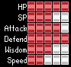

 Erin

Class- Mage

Primary Weapon- Rapier

Instrument- Electric Guitar

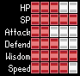

 Joss

Class- The Guy

Primary Weapon- N/A

Instrument- Acoustic Guitar

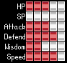

 Harold

Class- Cleric

Primary Weapon- Knives

Instrument-

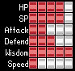

 Dwight

Class- Brawler

Primary Weapon- Axe

Instrument- Trumpet

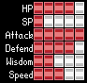

 Ryan

Class- Cleric

Primary Weapon- Shovel

Instrument- Metal Guitar

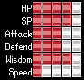

 Hair Wizard

Class- Mage

Primary Weapon- Wand

Instrument- Drums

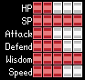

 Mitsy

Class- Rogue

Primary Weapon- Ray Gun

Instrument- Keyboard

